SIES COLLEGE OF ARTS, SCIENCE AND COMMERCE, SION(W)

DEPARTMENT OF ENGLISH

GUEST LECTURE BY “TEACH FOR INDIA”

DATE TIME AND OF THE EVENT: 22nd July, 2023, 9:00 am to 11 am

AIMS AND OBJECTIVES : To gain insights on “Teach for India” as an organization that works towards educating children and improving schooling facilities.

LOCATION: Auditorium

NO. OF PARTICIPANTS: 50

NAME OF RESOURCE PERSON: Mr. Keshav Nautiyal, Ms. Joyoti Chowdhury and Ms. Urvashi Parmar

REPORT: They spoke about the problems that prevent children from having access to education. Furthermore, the effects of these problems were also presented with accurate data. This event turned out to be helpful for all the students as it made them aware about this organization that works for massive social improvement. The speakers also introduced the students to volunteering, internship and fellowship opportunities offered by the organization. They also shared about their personal experiences throughout the fellowship. Aarti Konar, a student from TYBA English Literature course has been volunteering there for few years and her valuable inputs also provided the students with more knowledge. The event ended by an interactive session where the students cleared their doubts.

BENEFITS: The students could understand about the current situation of education accessibility in the country. The event helped them to learn the ways in which these problems can be eliminated. It also made them aware about the career prospects in this organization.

Annexure 2: Attandence Record:

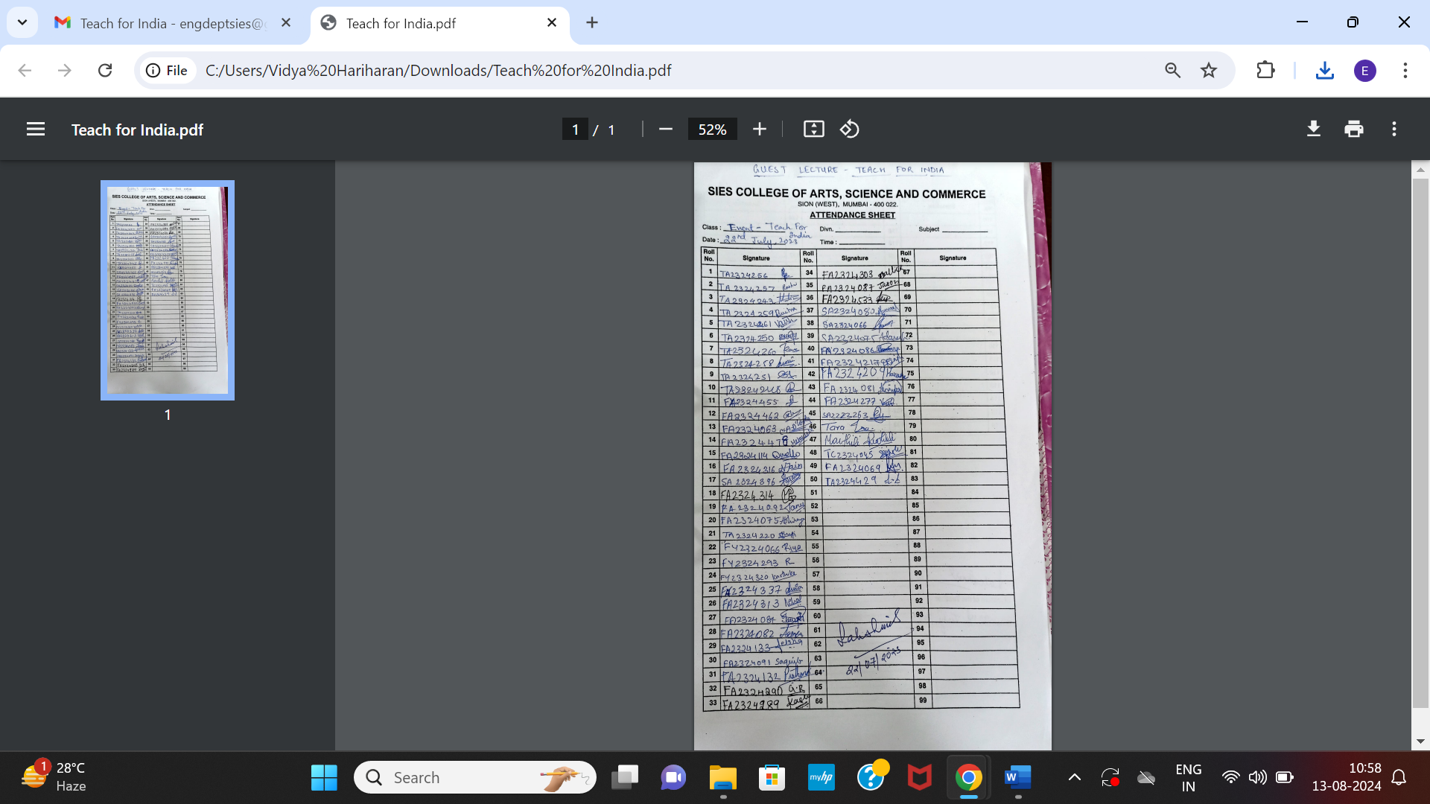

Annexure 3 : Photos

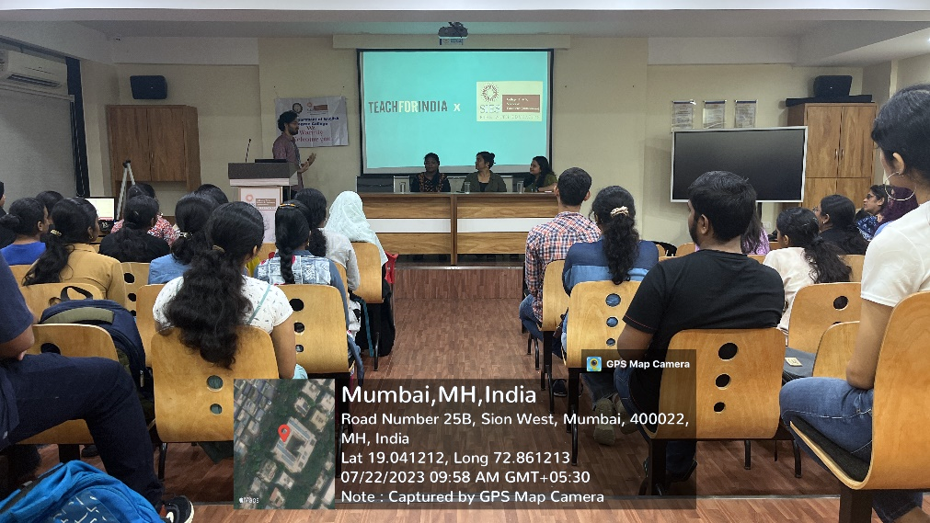

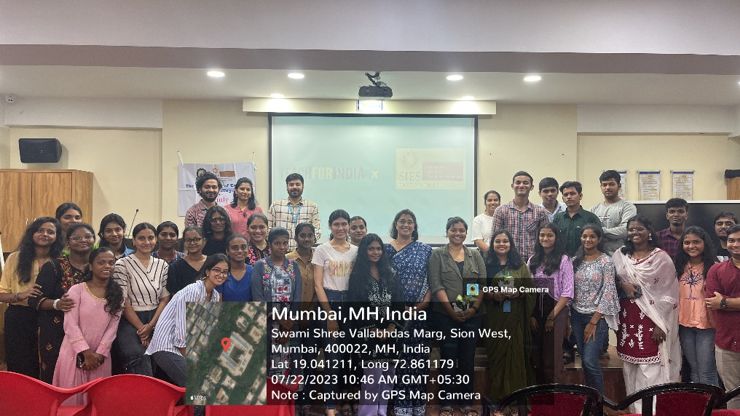

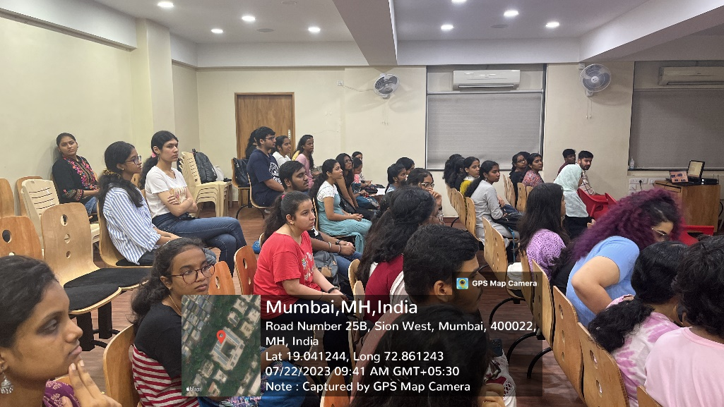

Report prepared by:

Vidya Hariharan

Sign of HOD:

Prof. Dr. Lakshmi Muthukumar